Comics Terminology

This document will relate all the vocabulary terms that you might use to create your own comics, spin off from Hélène and the Disappearing Gamers.
You might reproduce the Comics Lexicon picture just below, but without the vocabulary and create a guessing game with your students.
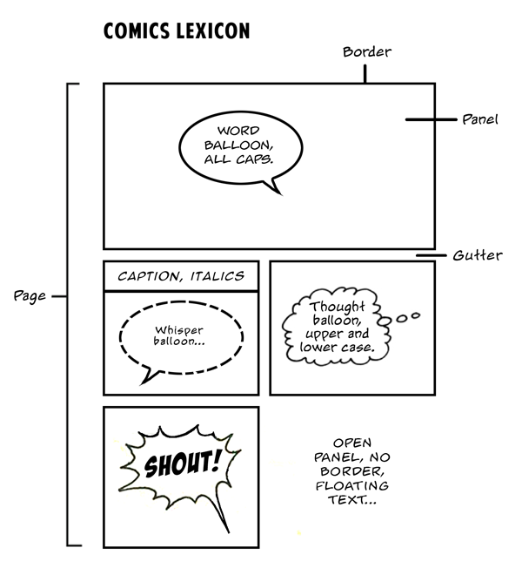

Important vocabulary :
• A panel is a drawing on a page which contains a segment of action. There might be one or many panels on a page. It affects the timing or pacing of a story, depending on their size, shape and style. Use your imagination to create one which copes with the story!
• The gutter is the space between panels.
• A splash is a large illustration that introduces a story, a character or an important event in the story. They often have the full size of the page, sometimes they take two pages.
• A caption is a little dialogue box that appears generally in the upper corner of a panel. The words in the caption often give voice to a narrator, but can also be used for a characters’ thoughts or a dialogue.
• Sounds effects are words that mimic sounds, they are non-vocal sound that illustrate a sound. They are also called onomatopoeia.
Examples : Achoo for sneezing, bang for a loud noise, bleep for a digital noise, boing for something that jumps, buzz for a buzzing sound; ect….
• A tier is a singular row of panels.
Another picture, to illustrate clearly the type of balloons that you can use (it is more simple to illustrate with images than words in this specific context).
