THE THREE BEARS’ HOUSE
Complete the house, draw:
In the kitchen (downstairs)… In the bedroom (upstairs)…
Baby Bear’s chair a small bed
Mother Beaar’s chair a medium bed and a blanket
Father Bear‘s chair a big bed and a pillow
The door a wardrobe
The table
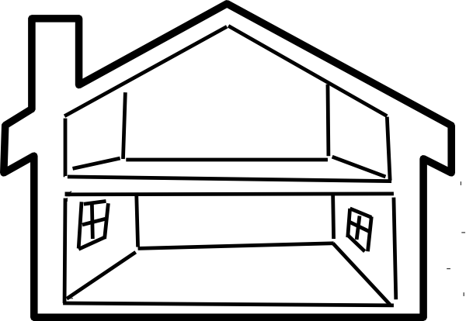
Curtains on the windows
